Risk and Returns: The Sharpe Ratio

*Songtao Song*

1. **Introduction to Sharpe Ratio**

An investment may make sense if we expect it to return more money than it costs. But returns are only part of the story because they are risky - there may be a range of possible outcomes. How does one compare different investments that may deliver similar results on average, but exhibit different levels of risks?

Enter William Sharpe. He introduced the *reward-to-variability ratio* in 1966 that soon came to be called the Sharpe Ratio. It compares the expected returns for two investment opportunities and calculates the additional return per unit of risk an investor could obtain by choosing one over the other. In particular, it looks at the difference in returns for two investments and compares the average difference to the standard deviation (as a measure of risk) of this difference. A higher Sharpe ratio means that the reward will be higher for a given amount of risk. It is common to compare a specific opportunity against a benchmark that represents an entire category of investments.

The Sharpe ratio has been one of the most popular risk/return measures in finance, not least because it's so simple to use. It also helped that Professor Sharpe won a Nobel Memorial Prize in Economics in 1990 for his work on the capital asset pricing model (CAPM).

This article was going to learn about the Sharpe ratio by calculating it for the stocks of the two tech giants Facebook and Amazon. As a benchmark, we'll use the S&P 500 that measures the performance of the 500 largest stocks in the US.

1. # Importing required modules
2. **import** pandas as pd
3. **import** numpy as np
4. **import** matplotlib.pyplot as plt
6. # Settings to produce nice plots in a Jupyter notebook
7. plt.style.use('fivethirtyeight')
8. %matplotlib inline
10. # Reading in the data
11. stock_data = pd.read_csv('datasets/stock_data.csv', parse_dates=['Date'], index_col=['Date']).dropna()
12. benchmark_data = pd.read_csv('datasets/benchmark_data.csv',parse_dates=['Date'], index_col=['Date']).dropna()
13. **Plot & summarize daily prices and the S&P 500 Index**

Before we compare an investment in either Facebook or Amazon with the index of the 500 largest companies in the US, let's visualize the data, so we better understand what we're dealing with.

1. # Display summary for stock_data
2. **print**('Stocks\n')
3. stock_data.info()
4. **print**(stock_data.head())
6. # Display summary for benchmark_data
7. **print**('\nBenchmarks\n')
8. benchmark_data.info()
9. **print**(benchmark_data.head())
11. # visualize the stock_data
12. stock_data.plot(subplots=True, title='Stock Data')
14. # summarize the stock_data
15. stock_data.describe()
17. # plot the benchmark_data
18. benchmark_data.plot(title='S&P 500')
20. # summarize the benchmark_data
21. benchmark_data.describe()

The summaries for daily price of Amazon and Facebook:

Figure 1. Daily prices for Amazon and Facebook

The summaries for daily values of the S&P 500 Index

Figure 2. Daily values for the S&P 500

1. **The inputs for the Sharpe Ratio**

The Sharpe Ratio uses the difference in returns between the two investment opportunities under consideration. However, our data show the historical value of each investment, not the return. To calculate the return, we need to calculate the percentage change in value from one day to the next. We'll also take a look at the summary statistics because these will become our inputs as we calculate the Sharpe Ratio.

1. # calculate daily stock_data returns
2. stock_returns = stock_data.pct_change()
4. # plot the daily returns
5. stock_returns.plot()
7. # summarize the daily returns
8. stock_returns.describe()

The summaries of returns for daily prices were:

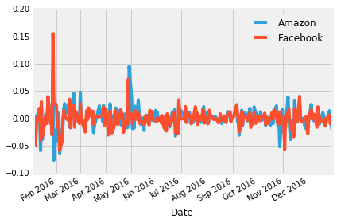

Figure 3. Daily Stock Returns

For the S&P 500, calculating daily returns works just the same way.

1. # calculate daily benchmark_data returns
3. sp_returns = benchmark_data['S&P 500'].pct_change()
5. # plot the daily returns
6. sp_returns.plot()
8. # summarize the daily returns
9. sp_returns.describe()

The results were:

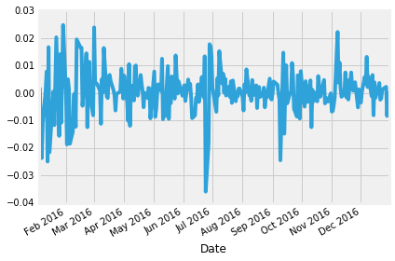

Figure 4. Daily the S&P 500 Returns

Next, we need to calculate the relative performance of stocks vs. the S&P 500 benchmark. This is calculated as the difference in returns between daily stock returns and daily the S&P 500 returns for each day.

1. # calculate the difference in daily returns
2. excess_returns = stock_returns.sub(sp_returns, axis=0)
4. # plot the excess_returns
5. excess_returns.plot()
7. # summarize the excess_returns
8. excess_returns.describe().transpose()

The summaries were:

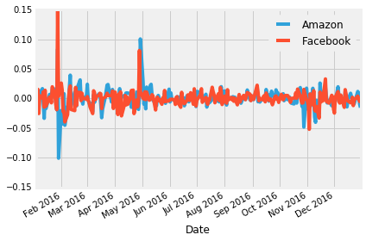

Figure 5. Returns for Amazon and Facebook vs. S&P 500

1. **The Sharpe Ratio**

Now we can finally start computing the Sharpe Ratio. First, we need to calculate the average of the excess returns. This tells us how much more or less the investment yields per day compared to the benchmark.

1. # calculate the mean of excess_returns
2. # ... YOUR CODE FOR TASK 8 HERE ...
3. avg_excess_return = excess_returns.mean()
5. # plot avg_excess_returns
6. avg_excess_return.plot(kind='bar', title='Mean of the Return Difference')

Figure 6. Mean of the Return Difference

The Figure 6 shows that there was quite a bit of a difference between average daily returns for Amazon and Facebook.

Next, we calculate the standard deviation of the excess returns. This shows us the amount of risk an investment in the stocks implies as compared to an investment in the S&P 500.

1. # calculate the standard deviations
2. sd_excess_return = excess_returns.std()
4. # plot the standard deviations
5. sd_excess_return.plot.bar(title='Standard Deviation of the Return Difference')

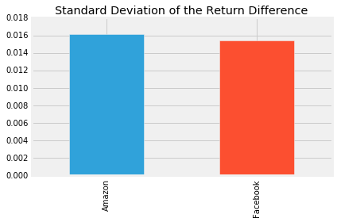

Figure 7. Standard Deviation of the Return Difference

The result is now finally the Sharpe ratio and indicates how much more (or less) return the investment opportunity under consideration yields per unit of risk. Then, The Sharpe Ratio is often annualized by multiplying it by the square root of the number of periods. We have used daily data as input, so we'll use the square root of the number of trading days (5 days, 52 weeks, minus a few holidays): √252.

1. # calculate the daily sharpe ratio
2. daily_sharpe_ratio = avg_excess_return.div(sd_excess_return)
4. # annualize the sharpe ratio
5. annual_factor = np.sqrt(252)
6. annual_sharpe_ratio = daily_sharpe_ratio.mul(annual_factor)
8. # plot the annualized sharpe ratio
9. annual_sharpe_ratio.plot.bar(title='Annualized Sharpe Ratio: Stocks vs S&P 500')

Figure 8. Annualized Sharpe Ratio: Stocks vs S&P 500

1. **Conclusion**

Given the two Sharpe ratios, which investment should we go for? In 2016, Amazon had a Sharpe ratio twice as high as Facebook. This means that an investment in Amazon returned twice as much compared to the S&P 500 for each unit of risk an investor would have assumed. In other words, in risk-adjusted terms, the investment in Amazon would have been more attractive.

This difference was mostly driven by differences in return rather than risk between Amazon and Facebook. The risk of choosing Amazon over FB (as measured by the standard deviation) was only slightly higher so that the higher Sharpe ratio for Amazon ends up higher mainly due to the higher average daily returns for Amazon.

When faced with investment alternatives that offer both different returns and risks, the Sharpe Ratio helps to make a decision by adjusting the returns by the differences in risk and allows an investor to compare investment opportunities on equal terms, that is, on an 'apples-to-apples' basis.